AWS Task 3

**Task Description:**

1.Create a S3 bucket, with no public access and upload files to the bucket & view the logs using cloudwatch for the uploaded files.  
  
**Screenshot 1 – AWS Console & Region Selection**

Step 1: Logged in to the AWS Management Console and selected the Mumbai (ap-south-1) region to ensure all resources are created in the same region.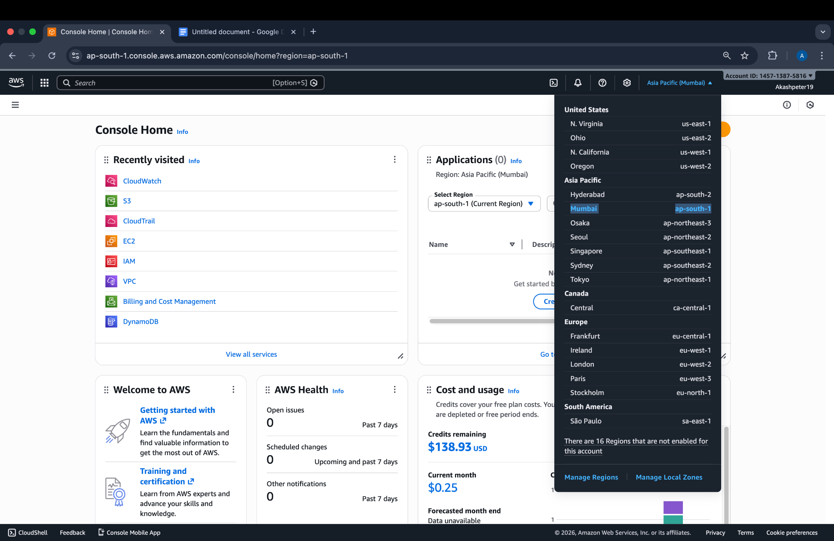

## 

## 

## **Screenshot 2 – S3 Bucket Creation**

**Step 2:** Created a new Amazon S3 bucket named **mytask3-s3-bucket** with **Block All Public Access** enabled to keep the bucket private.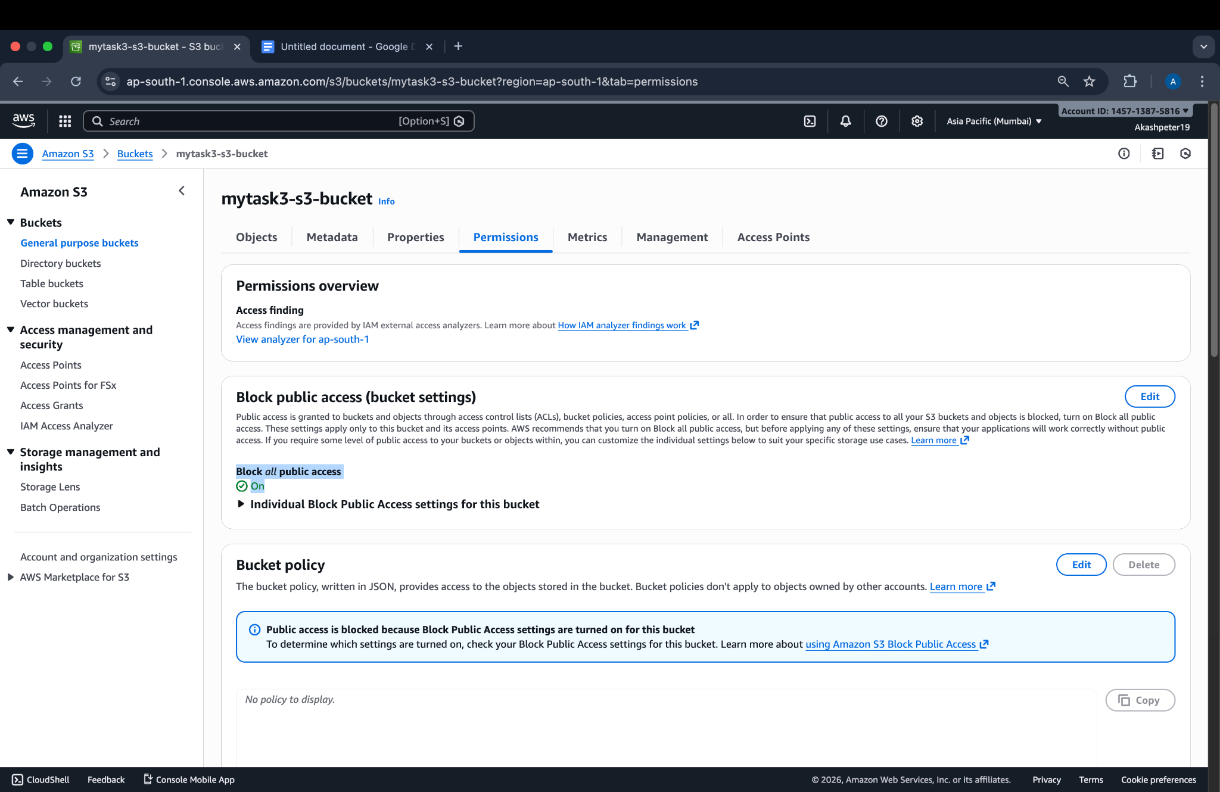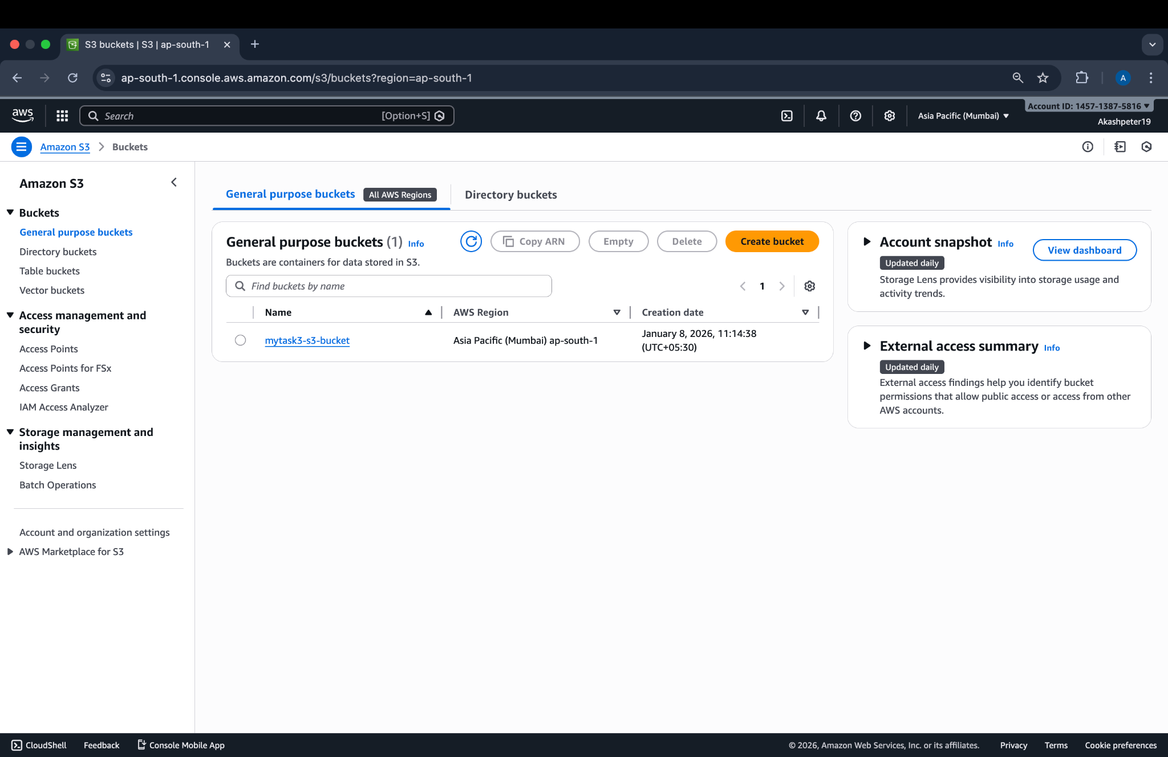

**Step 3 – Screenshot 3: Uploading File to S3**

Uploaded a file to the S3 bucket to validate successful object storage and prepare for logging verification.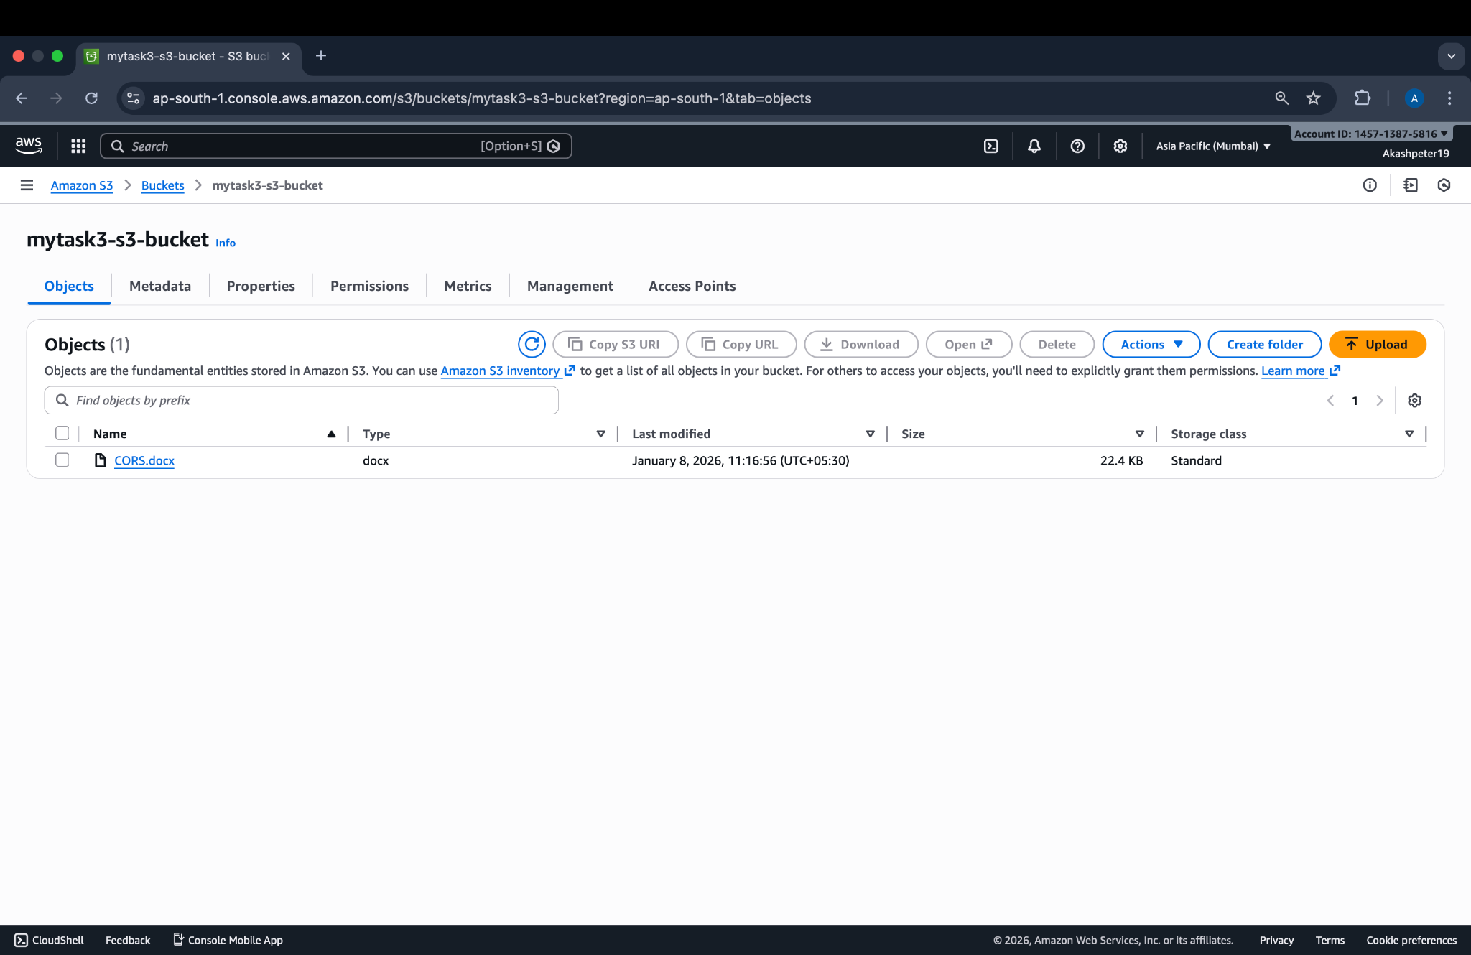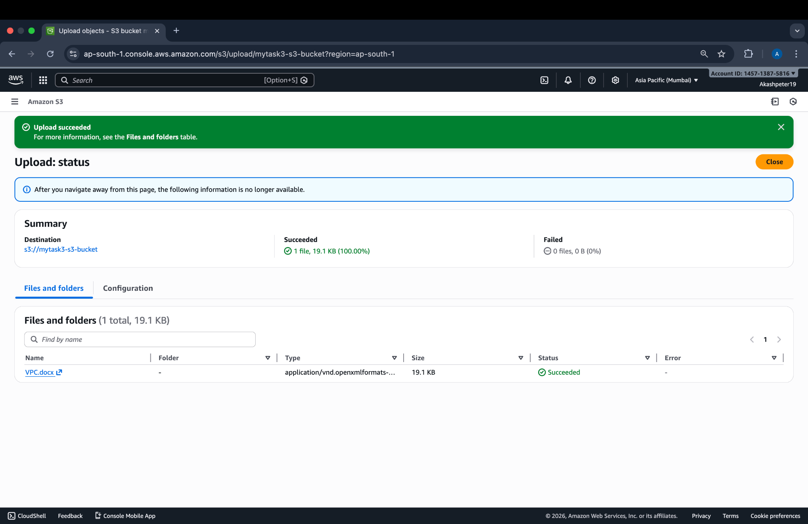

**Step 4 – Screenshot 4: CloudTrail Creation**

Created a CloudTrail trail named **s3-upload-trail** to record AWS API activity related to S3 operations.

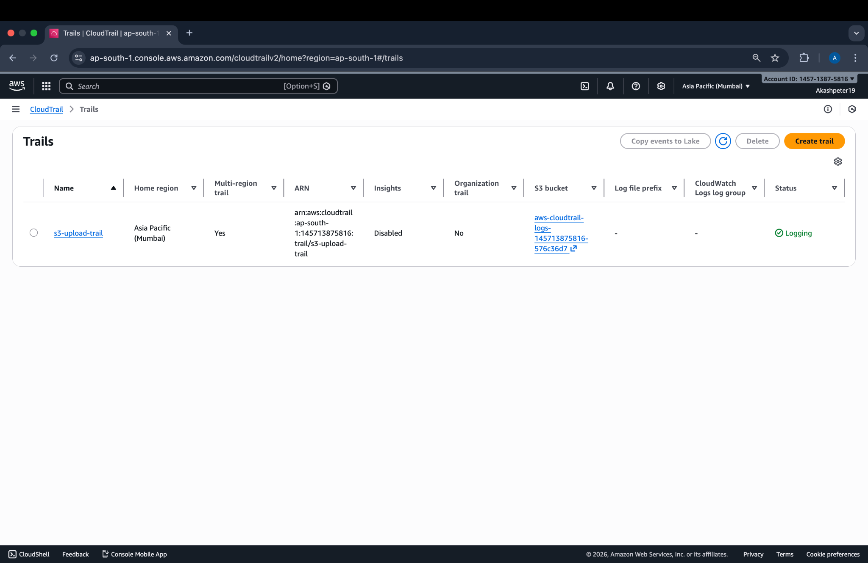

**Step 5 – Screenshot 5: Enabling S3 Data Events**

Enabled **S3 Data Events (Read and Write)** for the bucket **mytask3-s3-bucket** to capture object-level actions such as file uploads.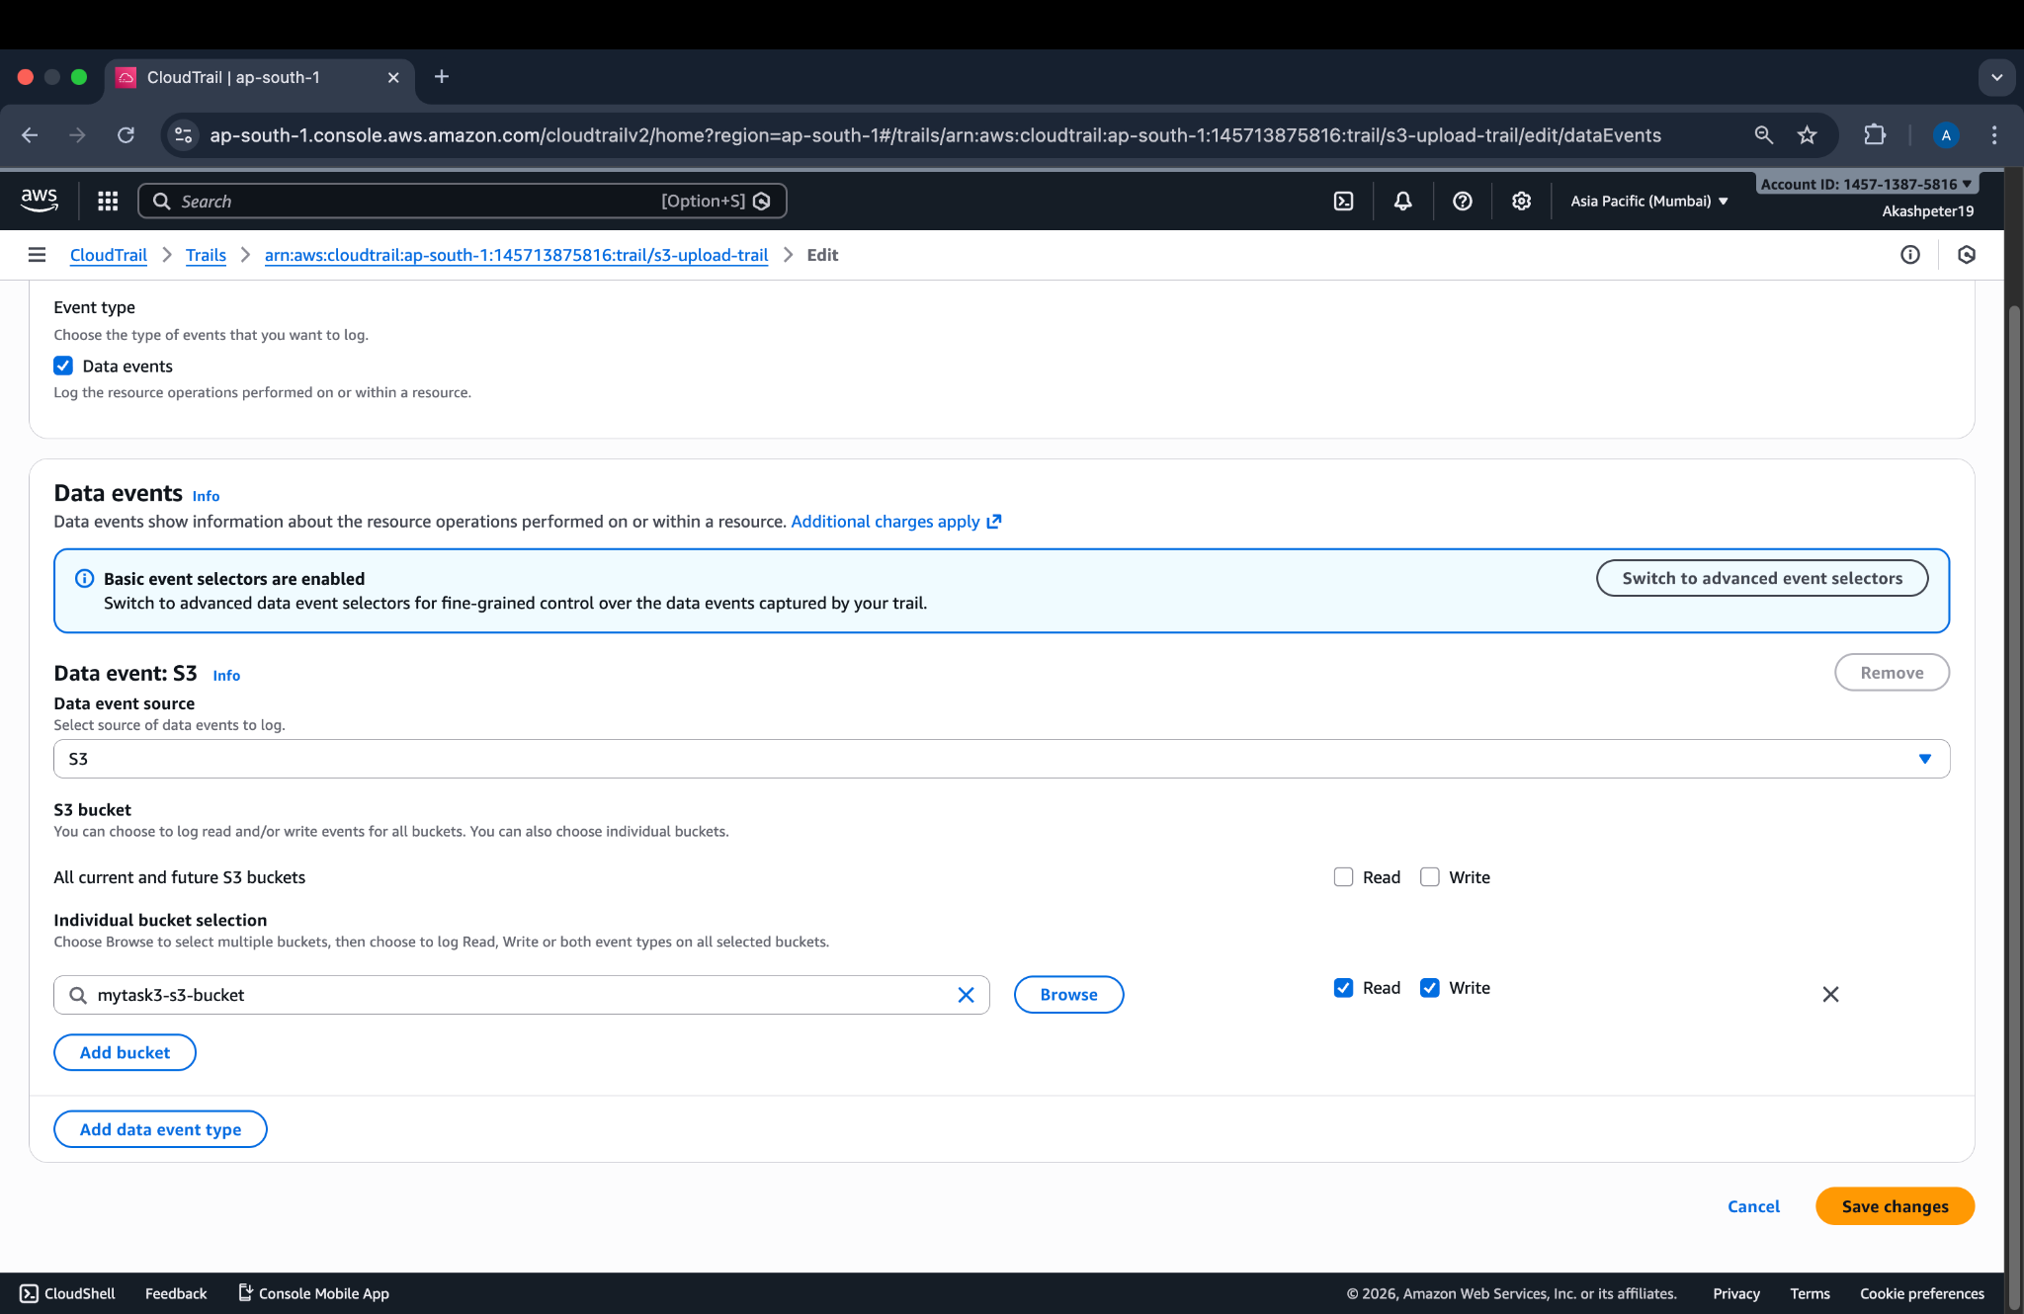

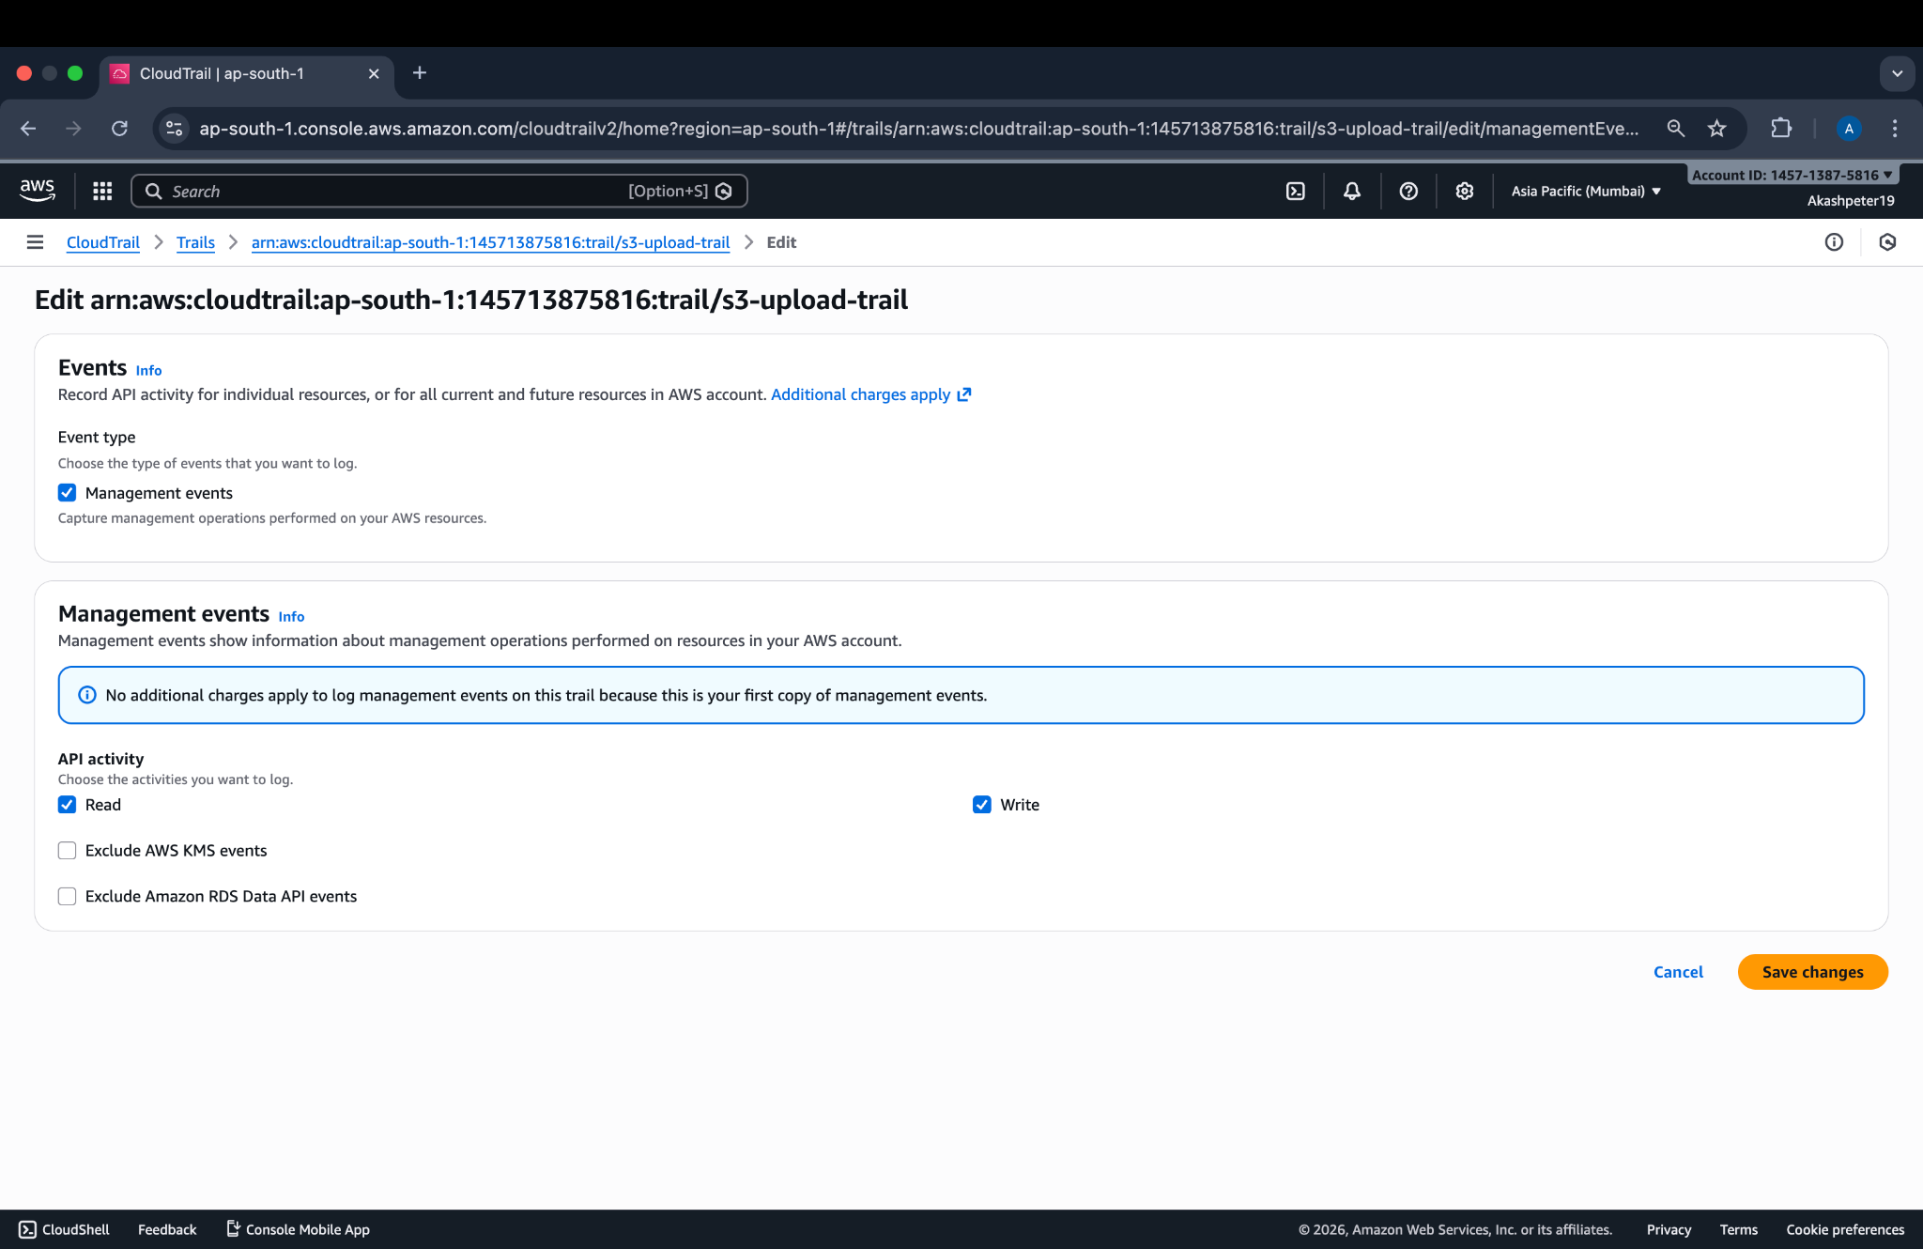

## **Step 6 – Screenshot 6: Enabling CloudWatch Logs**

Configured CloudTrail to send logs to **CloudWatch Logs** using the log group **/aws/cloudtrail/s3-upload-logs**.

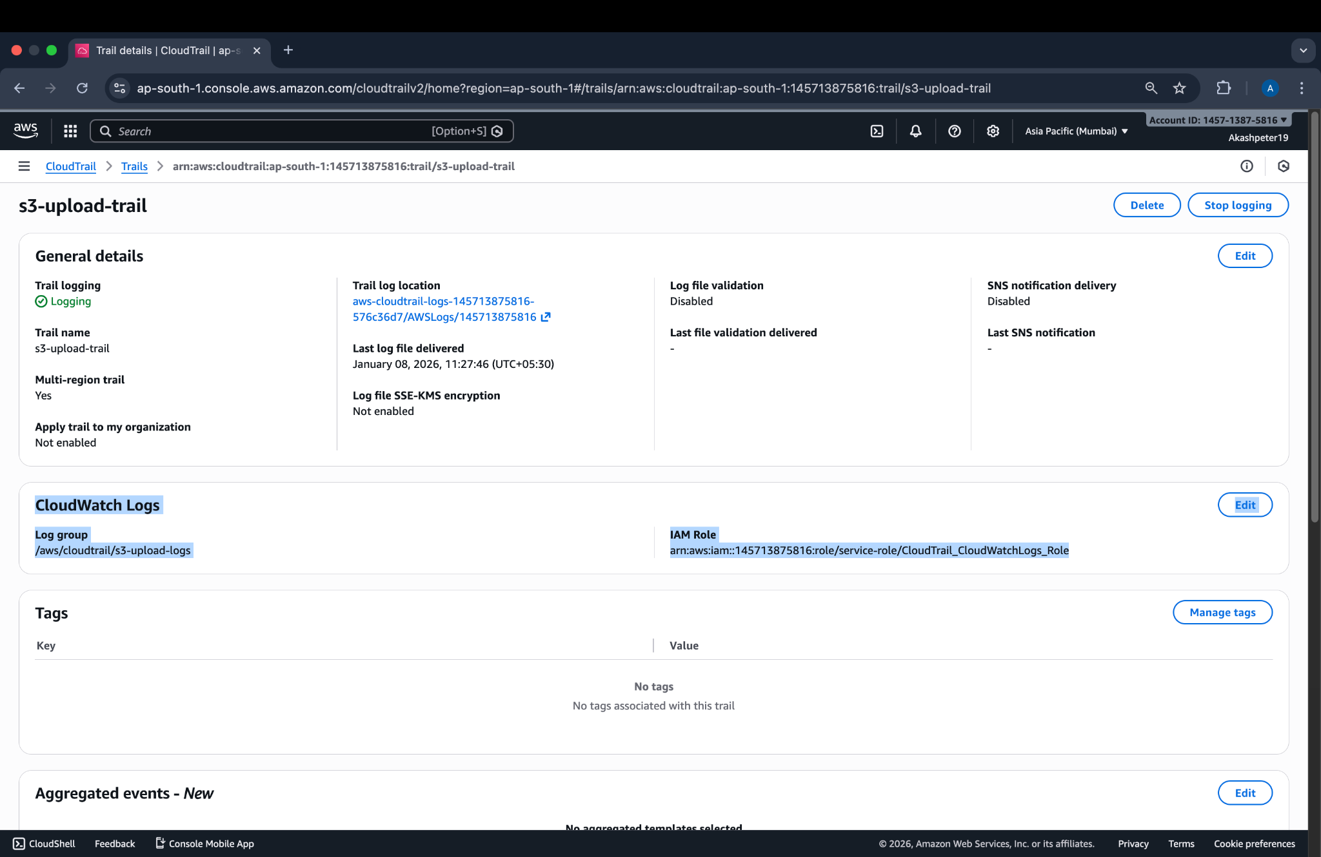

## **Step 7 – Screenshot 7: Uploading VPC.docx**

Uploaded the file **VPC.docx** to the S3 bucket to generate a **PutObject** event.  
  


## **Step 8 – Screenshot 8: CloudWatch Log Group**

Accessed the CloudWatch log group associated with CloudTrail to review logged S3 activity.

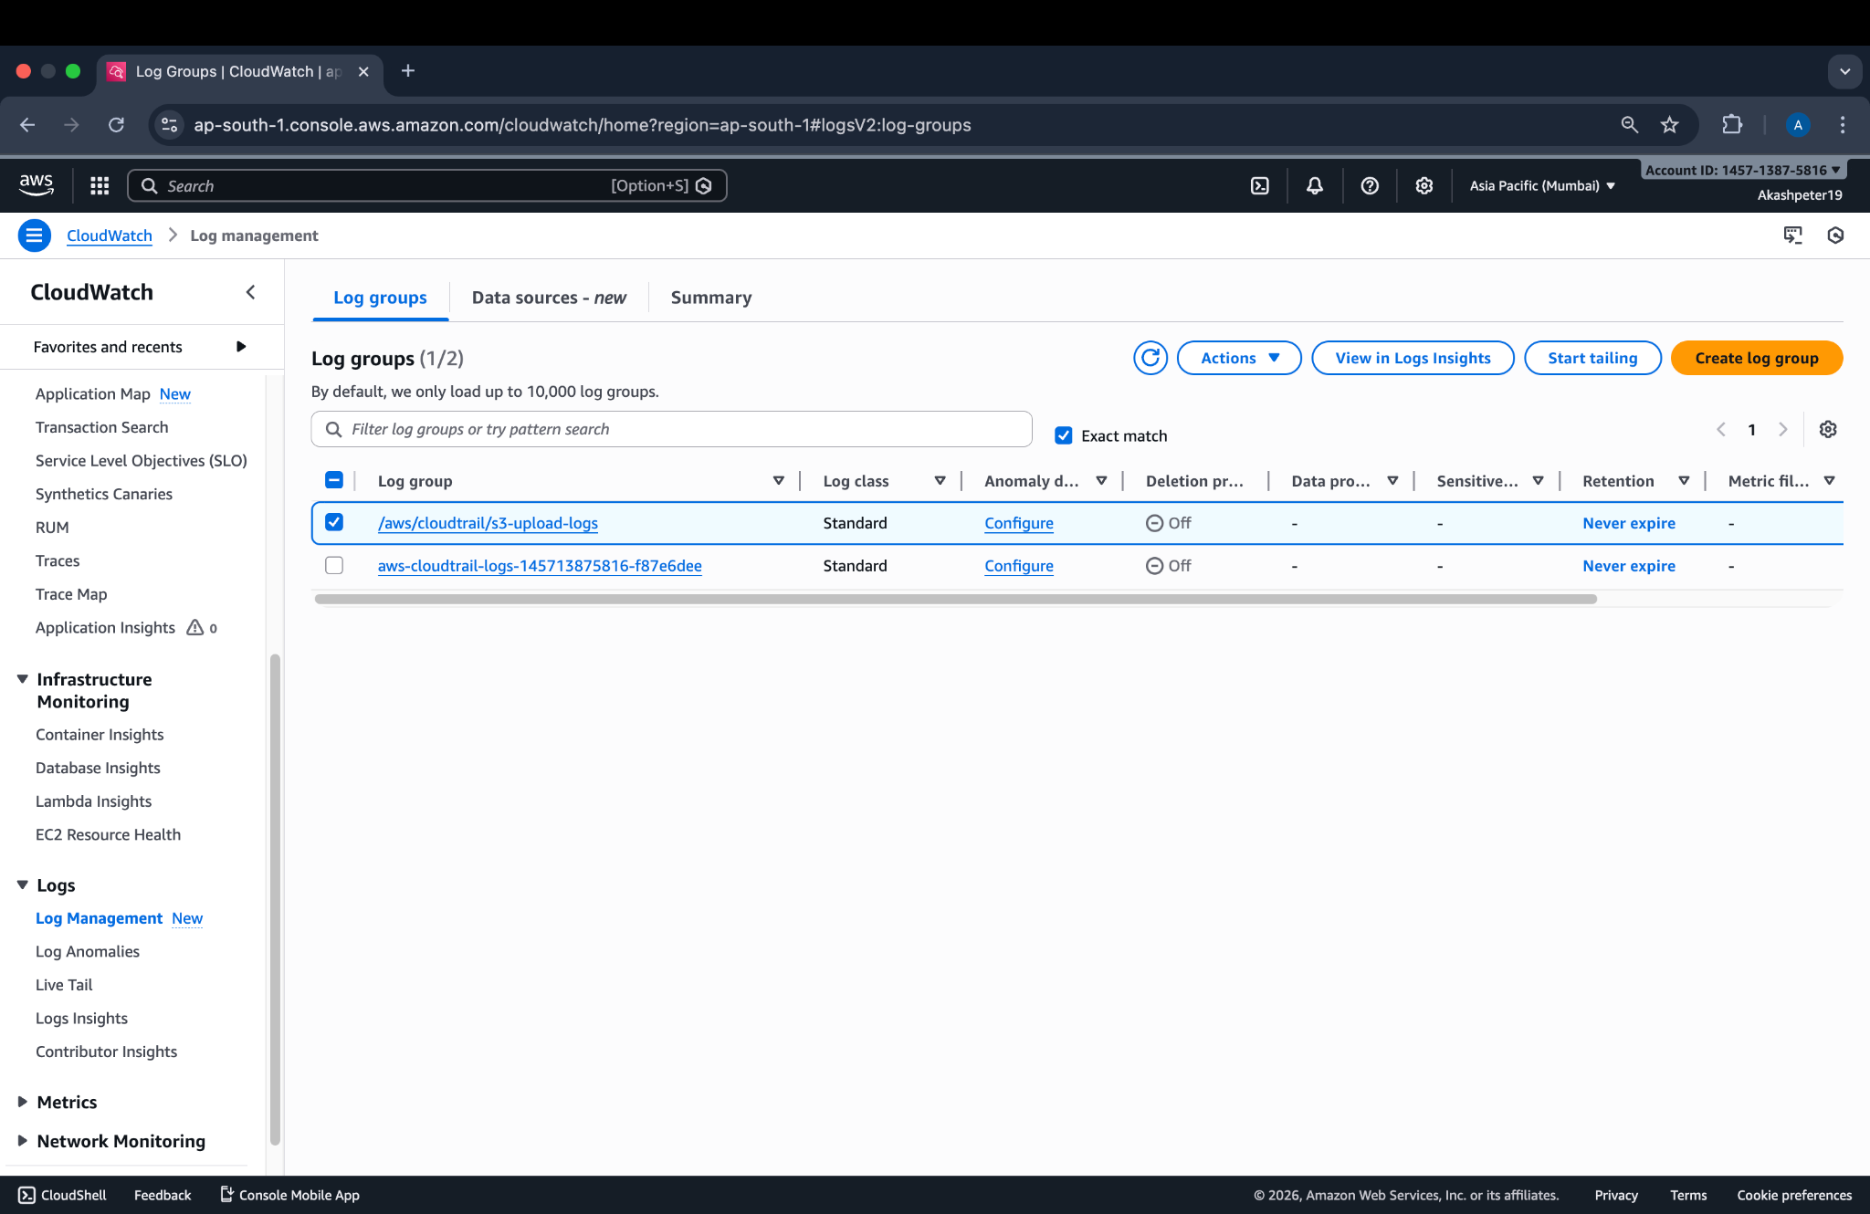

## **Step 9 – Screenshot 9: CloudWatch Log Stream**

Opened the relevant CloudTrail log stream for the **ap-south-1** region to locate S3 data events.

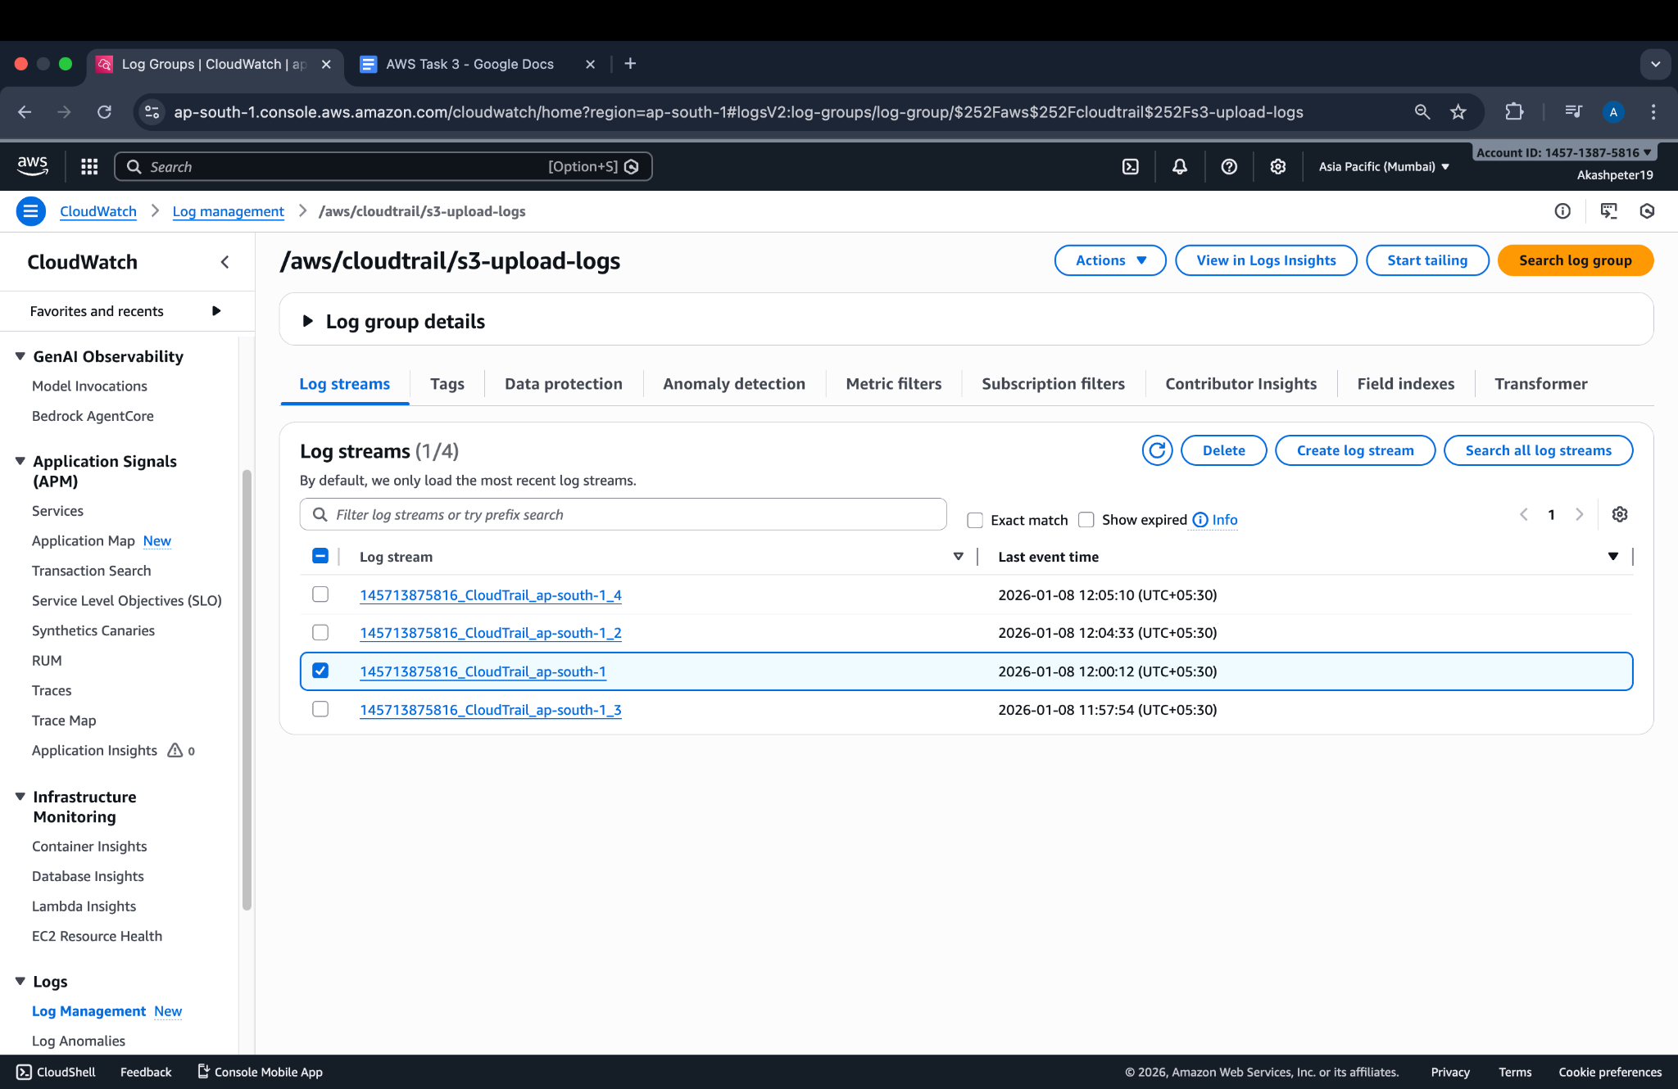  
  
  
  
  
  
  
  
  
  
  
  
  
  
  
  
  
  
  
**Step 10 – Screenshot 10: PutObject Event Verification**

Verified the **PutObject** event in CloudWatch Logs, confirming that the upload of **VPC.docx** to **mytask3-s3-bucket** was successfully logged.

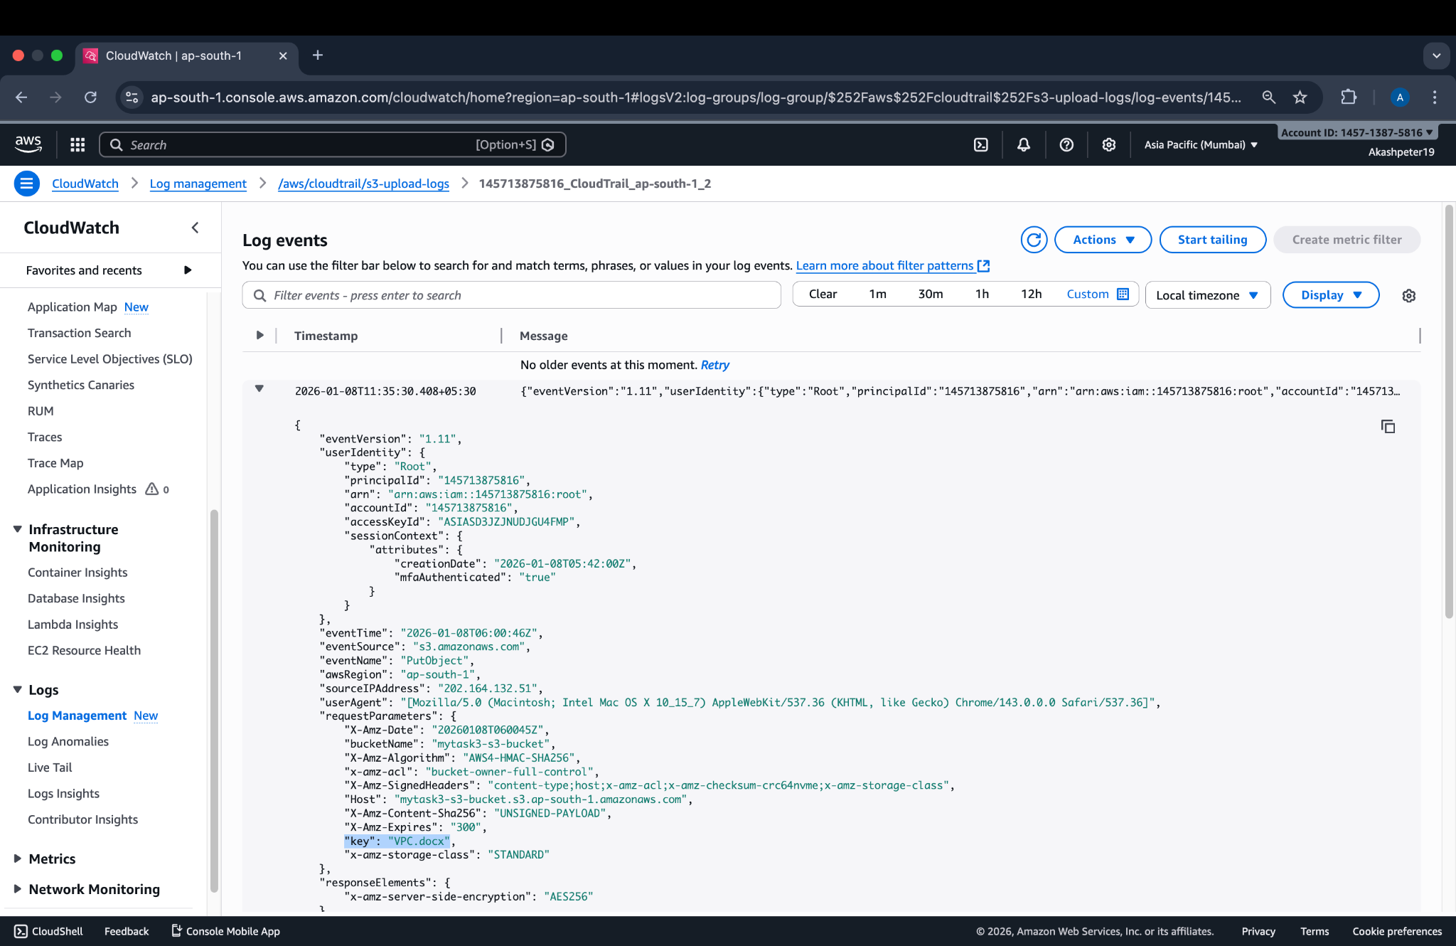

2.Launch two ec2-instances and connect it to a application load balancer, where the output traffic from the server must be an load balancer IP address  
  
**Step 1 – Screenshot 1: Launch EC2 Instance #1**

Launched the first EC2 instance using the Amazon Linux 2 AMI, selected instance type, configured network settings, and attached a security group that allows HTTP (port 80) traffic.  
  
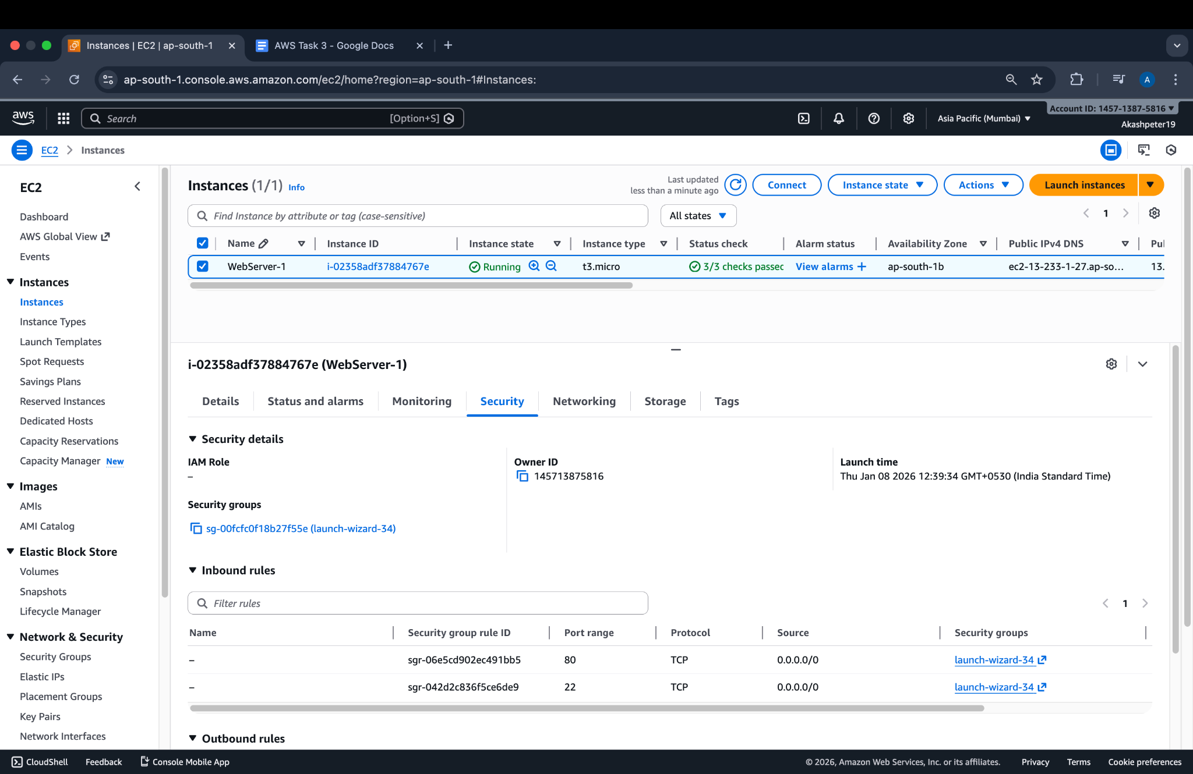

## 

## 

## 

## 

## **Step 2 – Screenshot 2: Launch EC2 Instance #2**

Launched the second EC2 instance with the same configuration as the first, ensuring it is in the **same VPC and subnet** for load balancer connectivity.

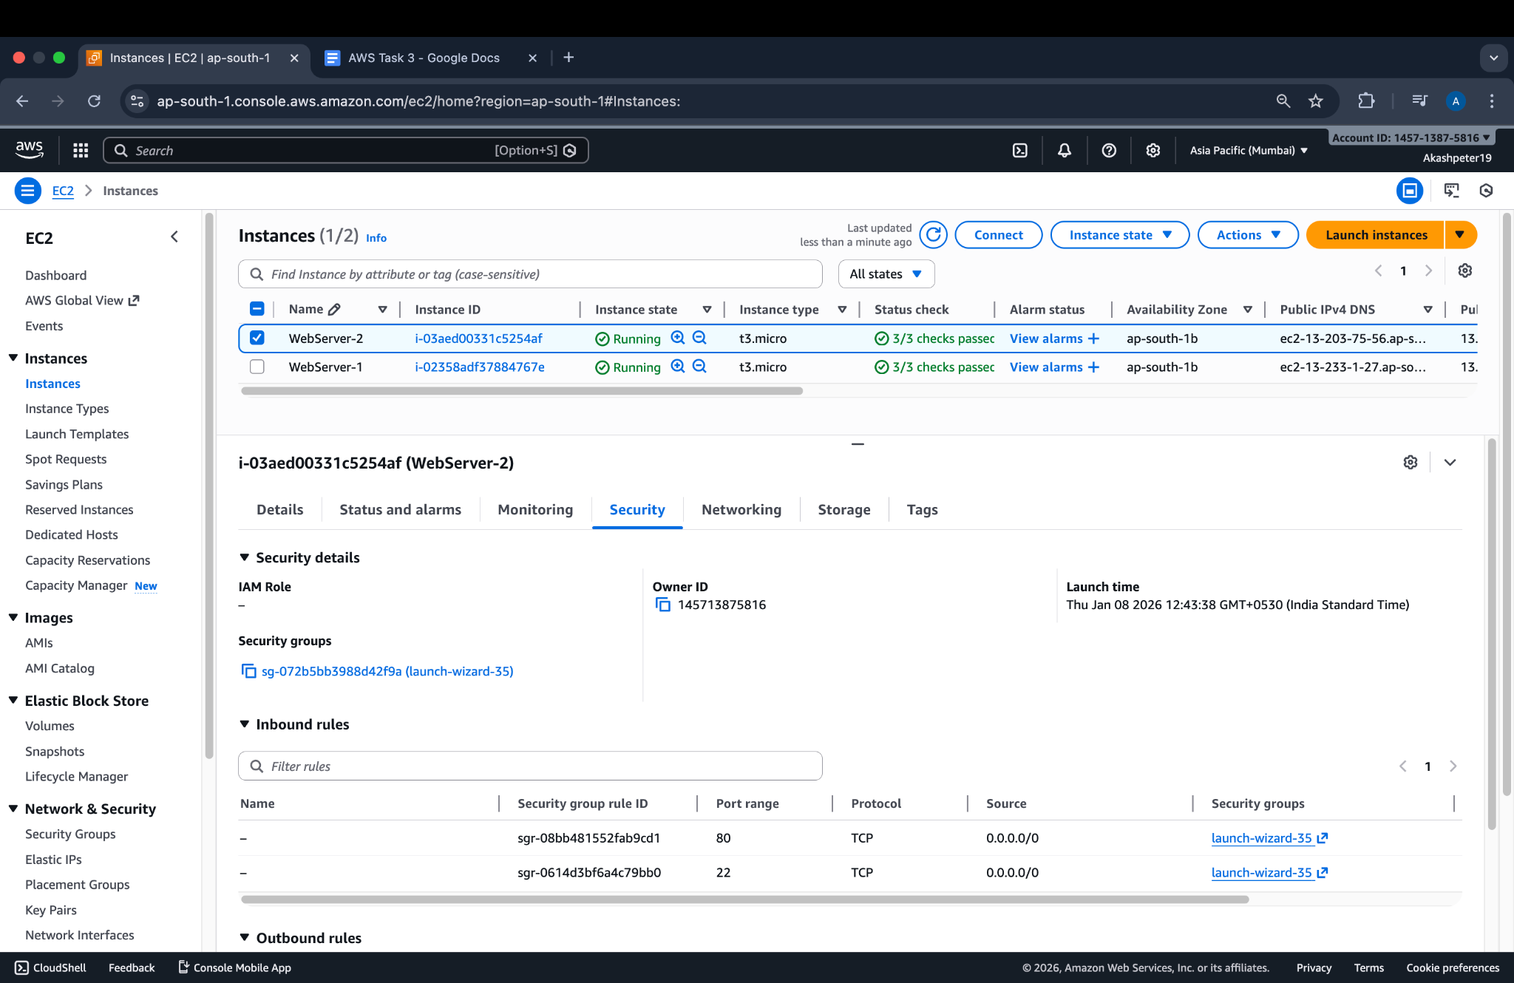

## **Step 3 – Screenshot 3: Install Sample Web Application**

Connected to each EC2 instance via SSH and installed a simple web server that displays a page identifying the instance (for testing).

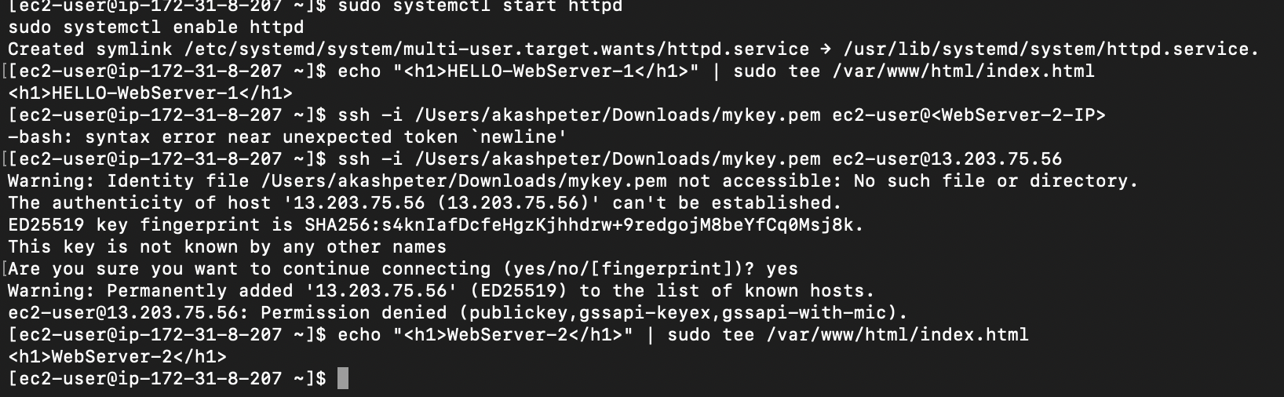

## **Step 5 – Screenshot 5: Create Application Load Balancer (ALB)**

Created an ALB:

* Type: **Application**
* Scheme: **Internet-facing**
* VPC: same as EC2 instances
* Listeners: HTTP (80)

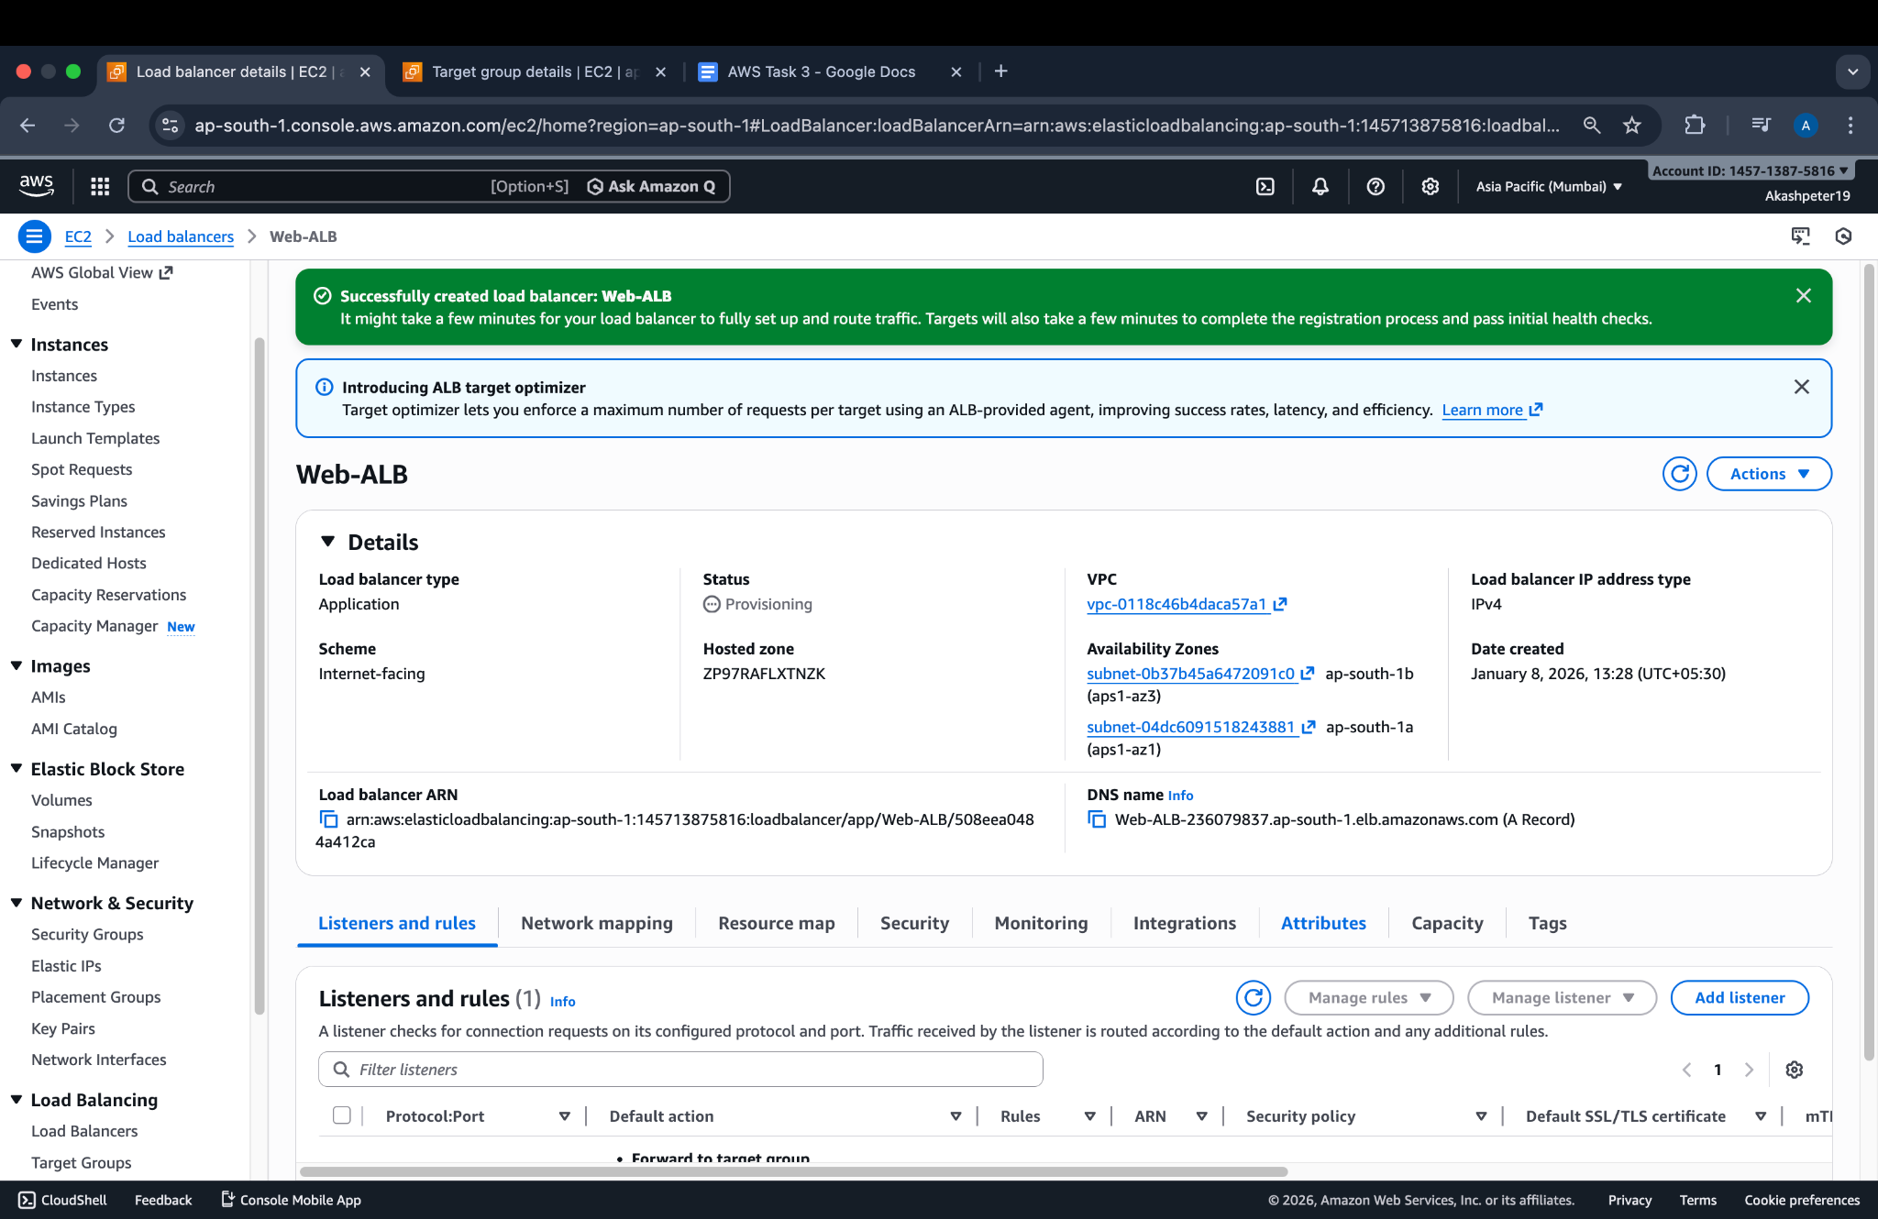

## 

## 

## **Step 6 – Screenshot 6: Configure Target Group**

Created a **target group** for the ALB:

* Target type: **Instance**
* Protocol: HTTP (80)
* Health check: HTTP (/)
* Added both EC2 instances to the target group

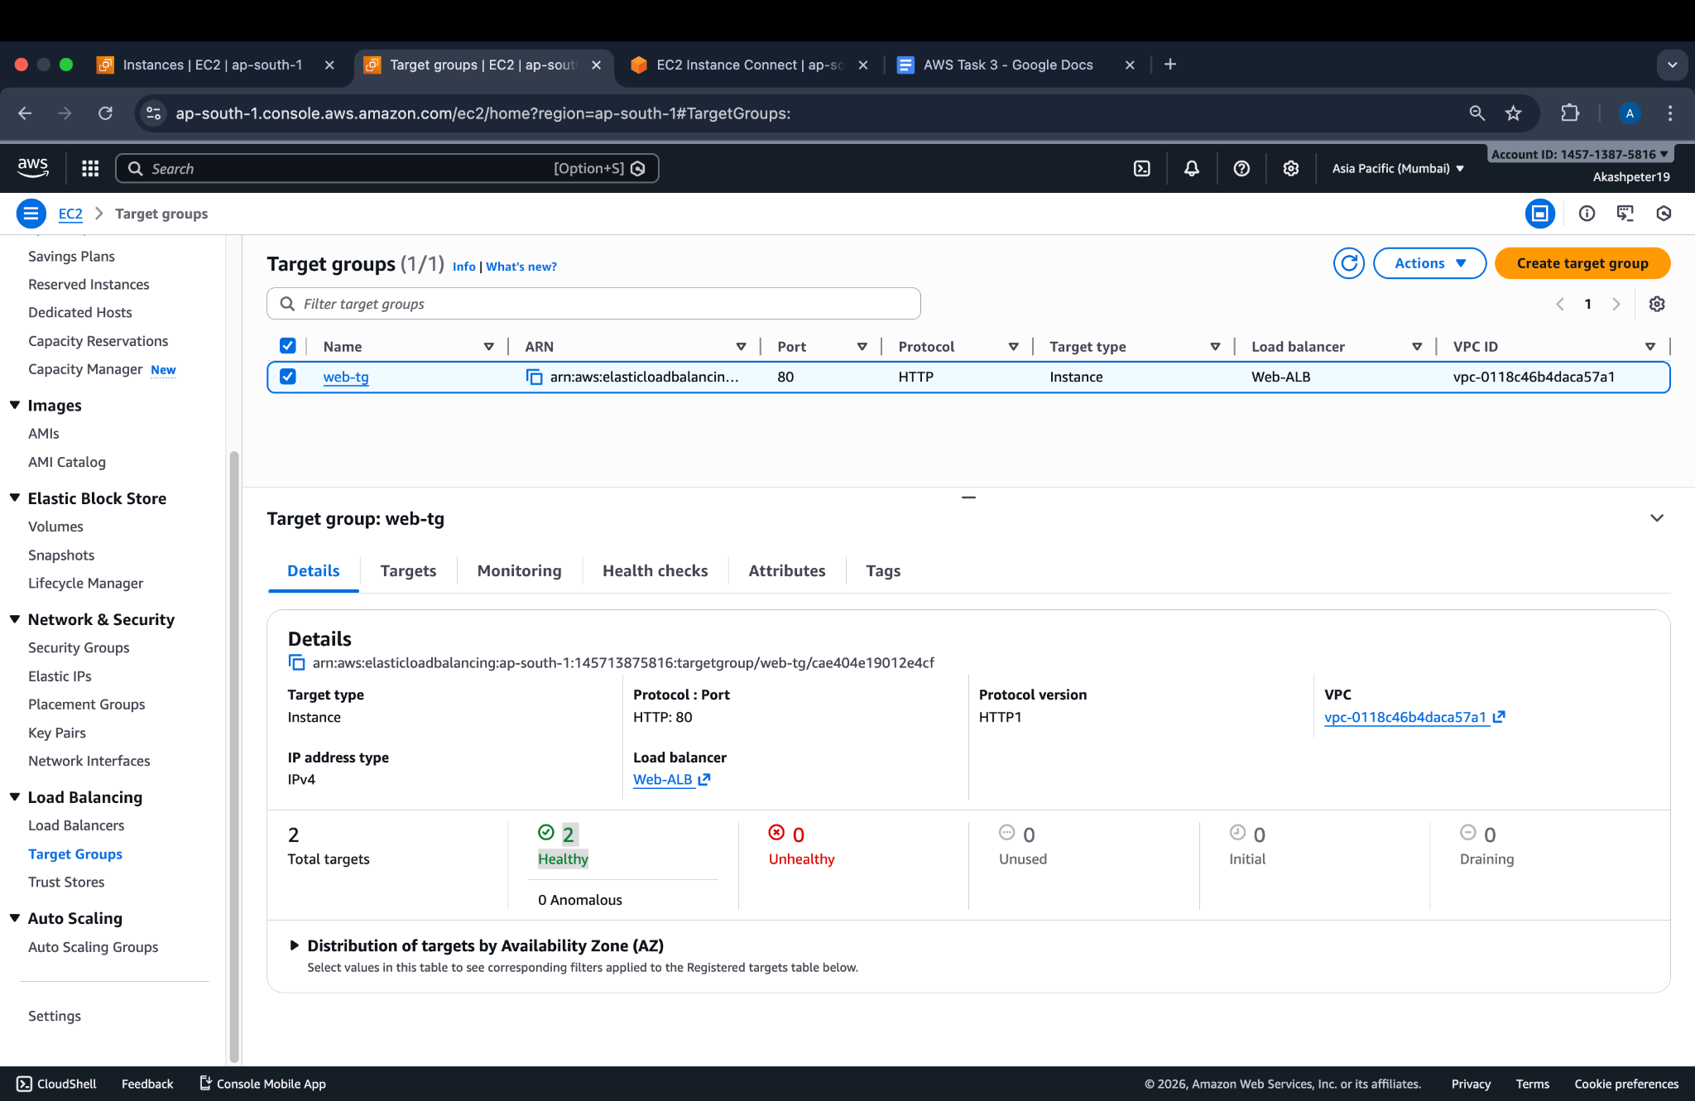

## 

## 

## 

## **Step 7 – Screenshot 7: Attach Target Group to ALB**

Attached the target group to the ALB’s **listener rules**, ensuring all HTTP traffic is forwarded to the EC2 instances.  
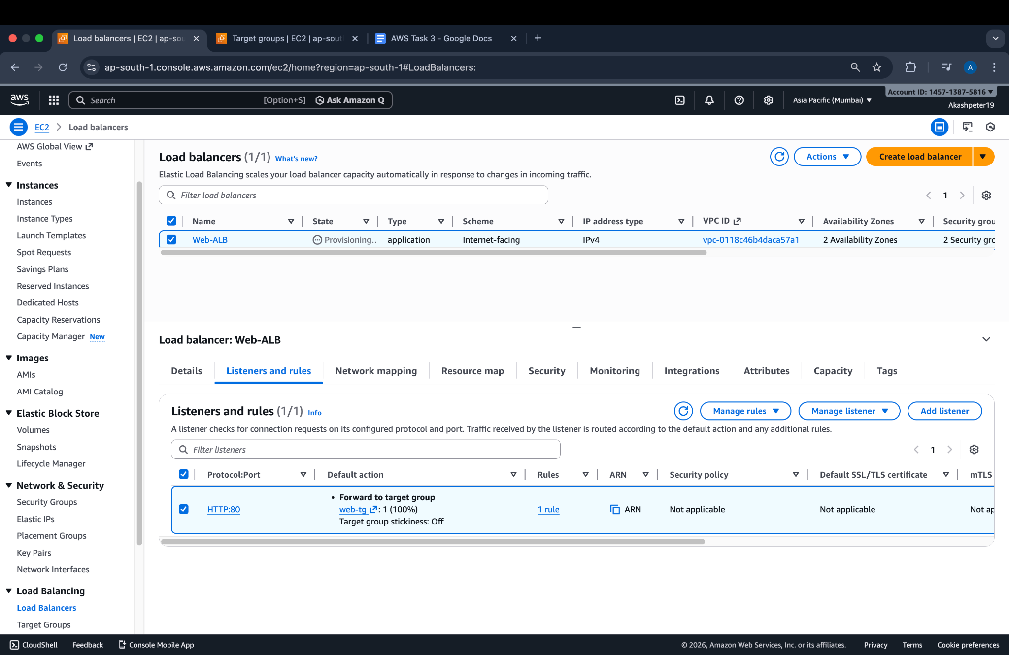

## **Step 8 – Screenshot 8: Verify ALB DNS**

Opened the ALB DNS URL in a browser to verify the web page is served through the ALB.

* Page should show instance info (rotates between Instance #1 and #2 on refresh if round-robin).  
  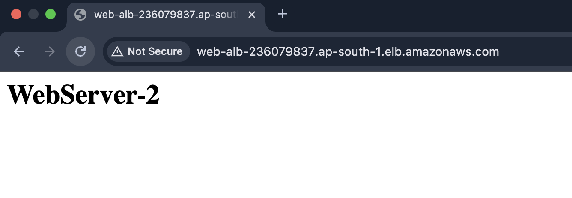

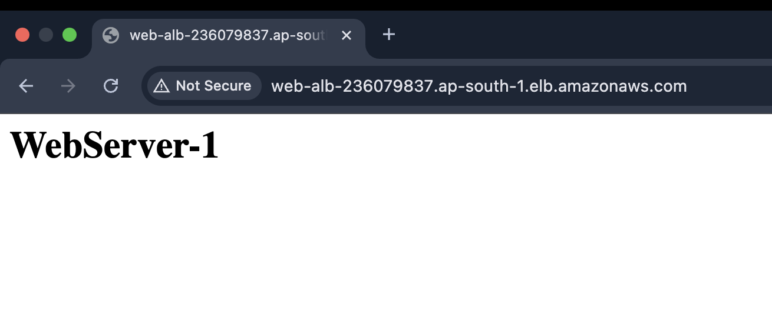

## 

## 

## 

## 

## 

## **Step 9 – Screenshot 9: Test Traffic Source IP**

Verified that requests to the web server are coming from the **ALB IP address** and not directly from client IP, ensuring traffic is properly routed via the load balancer.  
  
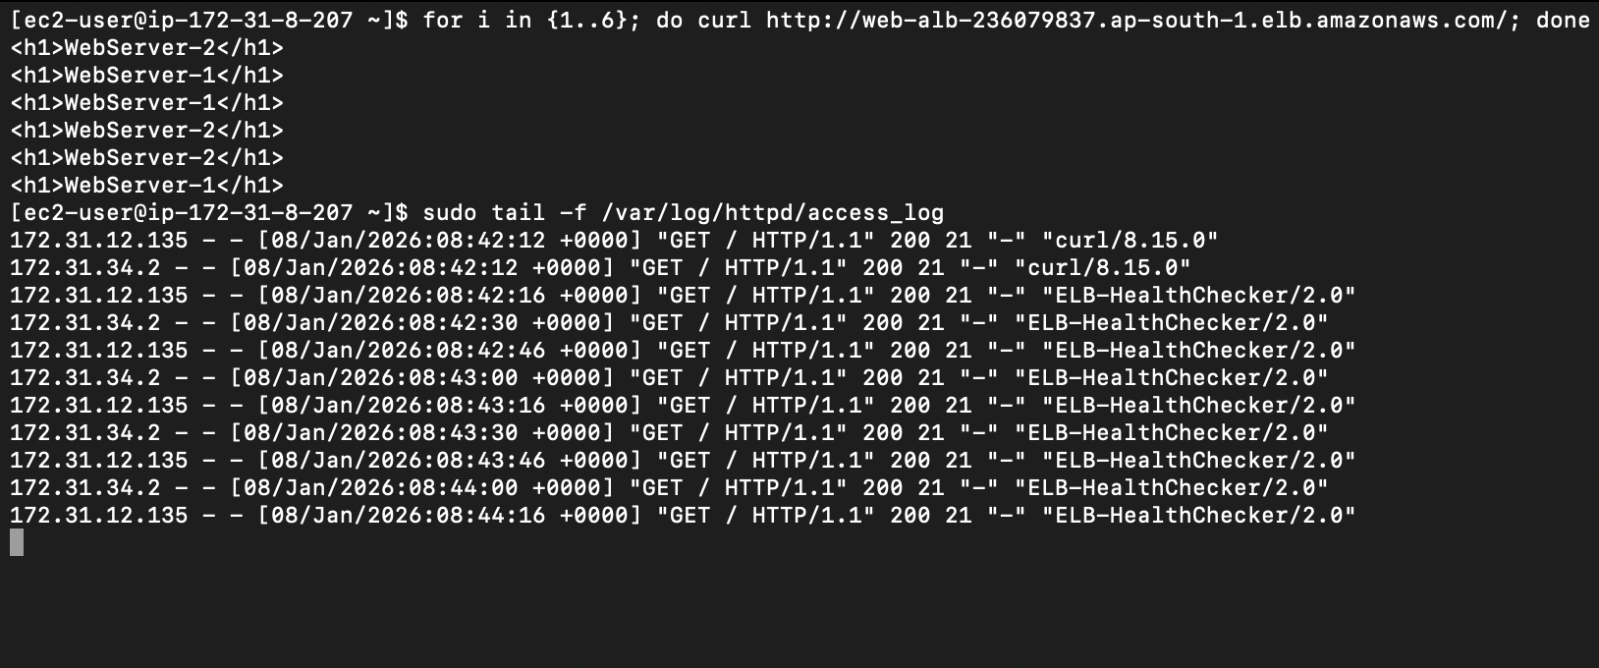

## 

## 

## 

## 

## 

## 

## 

## 

## 

## **Step 10 – Screenshot 10: Final Architecture / Summary**

Captured the **AWS console showing ALB with two registered EC2 instances**, demonstrating that the setup is complete and functioning as expected.